CONFIDENTIAL INFORMATION

DO NOT COPY



MCU-512 DVPV Service Life Test Debrief

SCR 07777

Revision 00

2020 McLaren Applied Proprietary

This document and any information contained herein is the confidential and copyright property of McLaren Applied Limited and without infringement neither the whole or any extract may be disclosed, loaned, copied or used for manufacturing or other purposes without their prior written consent and no liability is accepted for loss or damage from any cause whatsoever from the use of this document. The information contained within this specification has been prepared by McLaren Applied Ltd in good faith.

Contents

Document Change History 4

Abbreviations and Terminologies 4

1. Introduction 5

1.1 Reference Documents 5

2. Differences between DVTS and commissioned test system 6

2.1 DCDC Max Voltage 6

2.2 DC Link Min Voltage 6

2.3 KL30 Min Voltage 6

2.4 Load Profile 6

2.5 Coolant Temperature and Flow Rate 7

2.6 Environmental Chamber and Temperature Cycle Time 7

2.7 Additional Protection Measures 8

3. Test issues and Limitations 9

3.1 Test Conduct 9

3.1.1 Unit Temperature Damage 9

3.1.2 DCDC Dropouts 9

3.1.3 IGBT Temperature Noise 9

3.1.4 Inverter Over-Current Flag 9

3.1.5 Loss of UUT Communication 9

3.1.6 Parametric Test Failures 10

3.2 Test Hardware 10

3.2.1 HV Power Supply Bug 10

3.2.2 Huber Chiller Error 10

3.2.3 Electronic Load Issues 10

3.2.4 Coolant Leaks 10

3.2.5 Environmental Chamber Issues 11

3.3 Test Software 11

3.3.1 Speed Limitations 11

3.3.2 VPN Access 11

3.3.3 Logfile Splitting 11

3.3.4 10GB Database Limit 12

3.3.5 Negative Sleep Bug 12

4. Project Development issues 13

4.1 System Requirements 13

4.2 Pre Testing 13

5. Items to Carry Forward 14

5.1 Real Time Test Status Analysis 14

5.2 UUT fixturing 14

5.3 Remote Access 14

6. Recommended Actions 15

6.1 UUT Load Pulse Management 15

6.2 UUT Temperature Protection 15

6.3 Use an Updated Electronic Load 15

6.4 Update Chiller Error Handling 15

6.5 Update logfile splitting 15

# Document Change History

|  |  |  |  |
| --- | --- | --- | --- |
| **Revision** | **Date** | **Author** | **Comments** |
| 00 | 26/02/20 | HTE-RA | First Release |
|  |  |  |  |
|  |  |  |  |

# Abbreviations and Terminologies

|  |  |
| --- | --- |
| ATE | Automated Test Equipment |
| DVPV | Design Validation Product Validation |
| DVTS  HTOE  MCU  PTCE | Design Validation Test Specification  High Temperature Operating Endurance  Motor Control Unit  Powered Thermal Cycle Endurance |
| SRS | System Requirements Specification |
| UUT | Unit Under Test |

# Introduction

MCU-512 DVPV Service life testing took place between June – December 2019 at Parc Ltd. The test setup consisted of 4x liquid cooled MCU-512 units contained in an environmental chamber, connected to an ATE and laptop. See the DVTS for more details. PTCE testing commenced first, followed by HTOE. Each test had a 13-point parametric test performed at 25% intervals.

During service life testing (PTCE and HTOE), there were instances where the test conduct differs from the DVTS document. These differences were identified either at the test commissioning phase, or during the test itself and can be attributed to either UUT performance or test hardware/software limitations. This document also details issues that were seen during testing, which may be useful for someone implementing similar tests in the future.

## Reference Documents

|  |  |
| --- | --- |
| SCR 7654 | STE-3141 HV PSU Rack Operator Manual |
| SCR 7655 | Instructions for MCU-512 Functional Operation and Monitoring Test |
| DVTS | <https://mclaren.polarion.com/polarion/#/project/MCU512/wiki/Testing/DVTS> |
| SCR 07776 | Post Test Stator Phase Cable Investigation |
| Test Log Files | N:\Production\Production Released Products\072022008xxU\Test History\Endurance Test Results |
|  |  |
|  |  |
|  |  |
|  |  |
|  |  |
|  |  |

# Differences between DVTS and commissioned test system

## DCDC Max Voltage

During the commissioning phase when running the parametric test, the unit would fail to enable the DCDC at the maximum output voltage of 16V. This was reduced to 15V for the parametric test and 15.2V for the service life testing – where the requirement is to achieve 3.2KW from the first DCDC output pulse.

## DC Link Min Voltage

During the commissioning phase it was noticed that when running at DC link voltages below 550V, the DCDC output would either fail to enable or would be very noisy. A minimum set-point of 550V was used for Parametric and Service Life tests. The DVTS specifies 416V Min for the parametric test, and 480V Min for PTCE and HTOE.

## KL30 Min Voltage

During the commissioning phase it was noticed that when running at the minimum KL30 voltage specified as 8V, the inverter would often fail to enable, or would be very noisy (an audibly different tone could be heard from the stator). The KL30 min voltage was set to 9.0V for Parametric and PTCE tests. When commissioning the HTOE test (after PTCE completion), this had to be increased further to 9.2V due to one unit 1894307 failing to drive at 9.0V. Note these voltages are the supply setting, and do not account for any drop in the harness.

## Load Profile

The inverter pulse profile achievable differs from that specified in the DVTS, due to a ramping of the load and a delay between pulses. The approximate profile was as follows:

0.5s ramp up, 2.5s high (take measurements), 0.5s ramp down, then 0.5s delay between pulses.

The ramp rate is fixed and controlled by the embedded software. This was found to be around 1.15 A/ms. The delay between pulses was due to checking the pulse was off before switching to the next unit – to avoid having more than one loaded at once in case of an error. The IGBT temperatures are also checked between pulses.

For PTCE The DVTS specifies a ratio of 1 minute operational, 9 minutes non-operational during a cold phase, and the reverse for a hot phase. Due to the delays mentioned above and wanting to always complete a full sequence of load pulses, the following ratios were chosen.

Cold Phase operational: 1 complete pulse train of 10 load pulses (2 min 40s)

Cold Phase non-operational: No Load for 7 min 18s

Hot Phase operational: 1 complete pulse train of 10 load pulses (2 min 40s)

Hot Phase non-operational: No load for 0 min 0s

Note that the dead time and load ramping in the operational period was used to contribute the overall ratio, hence why the load profile was run continuously for the hot phase.

Inverter Crank Profile of 2 units During Commissioning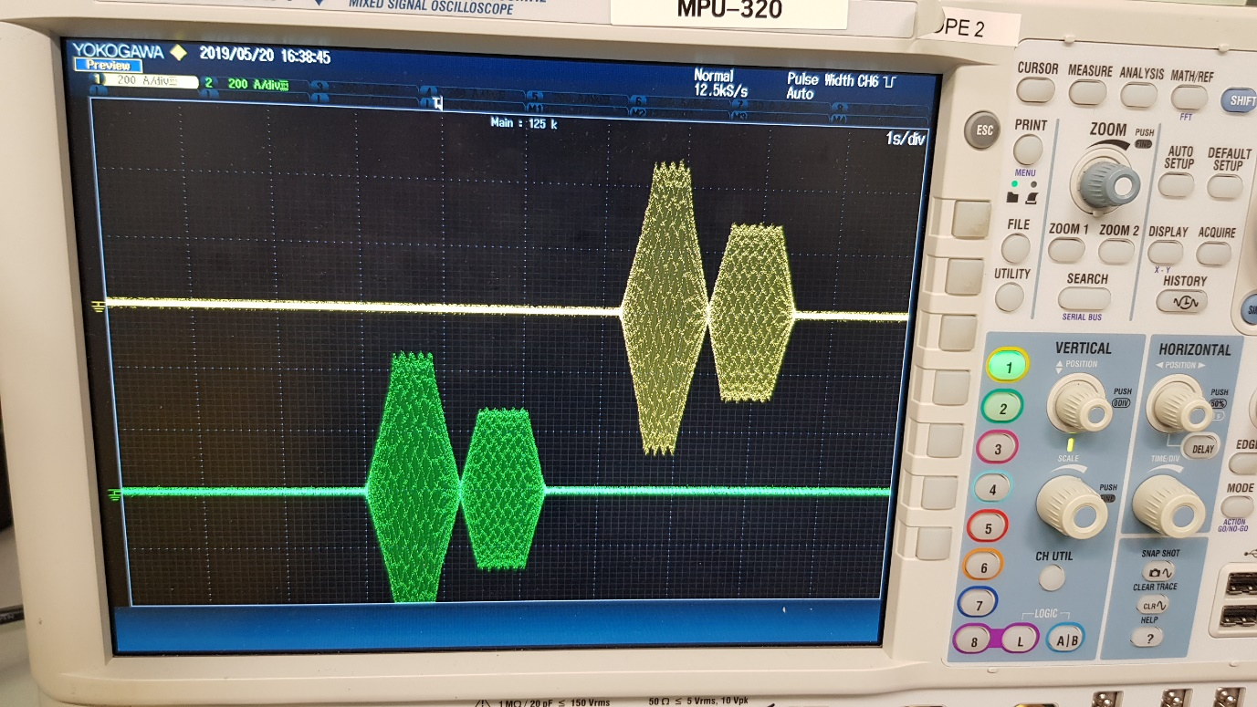

## Coolant Temperature and Flow Rate

The coolant temperature was not specified in the DVTS document. The values used were 0°C when the environmental chamber was cold (-20°C), and 30°C when the chamber was hot (85°C). This kept the IGBT temperatures below 50°C.

The pump pressure was fixed by the Huber Unichiller and was roughly 3 bar. It is estimated a flow rate of 3 -5 litres/minute was achieved.

## Environmental Chamber and Temperature Cycle Time

The temperature ramp up/down rate of the environmental chamber is specified in the DVTS as 4°C/Min with hot/cold durations of 30 minutes, producing a total cycle time of 1 hr 53 min. The ramp rates achievable by the chamber were as follows:

Cold duration: 40 min

Ramp up: 30 min (4°C/min)

Hot duration: 40 min

Ramp down: 50 min (2°C/min)

The increase in dwell time is due to the changes in load profile durations [2.4], and the cool down rate was the maximum the chamber could achieve. This means the total temperature cycle period achievable was 2 hr 40 min. As a result, the total test duration for PTCE was increased from 855 hr to 1000hr.

## Additional Protection Measures

There were measurements taken at certain intervals to ensure the correct operation of the test and protection of the UUTs:

**Every complete cycle (2hr 40min)**

* Check the coolant fill level from the Unichiller.

**Every ten load pulses (40s)**

* Check the coolant pump pressure from the Unichiller.
* Check the HV Supply current to identify if any loads are stuck on (e.g. UUT comms failure during load pulse) .
* Check for inverter over-current flag and attempt to reset if required.

**Every load pulse (4s)**

* Poll the inverter current once the output has been disabled, waiting for the current to drop within a timeout period – avoiding more than one unit being loaded at once.
* Check IGBT temperatures are within limits.

# Test issues and Limitations

## Test Conduct

### Unit Temperature Damage

During early commissioning at MTC a development unit was damaged due to excessive temperature as a result of running without coolant. This was due to operator error. This was remedied with the additional protection measures [2.7]. Refer to [6] for recommended actions.

### DCDC Dropouts

At the start of testing, it was observed that the DCDC output would sometimes fail to enable on certain units. This was most common when at the maximum DC Link/ KL30 voltage, and when the environmental chamber was cold. The DCDC output requires a minimum of 15A to regulate correctly, and the embedded software will turn off the output off within 5 seconds if 20A is not achieved.

During PTCE testing the DCDC start-up load was initially set to 3A with a 10V bootstrap supply. A 22mF capacitor was later added, which showed improvement but did not stop the issue completely. Finally, the bootstrap supply was changed and set to 13.3V, and a 14.5A resistor network added in addition to the 3A CC electronic load giving 17.5A total. This configuration completely cured the issue. The reason for using both the electronic load and a resistor network was down to an issue with setting certain currents on the electronic load [3.2.3].

### IGBT Temperature Noise

Throughout testing and across all units, there where instances of an IGBT temperature sensor reading 155.8°C (2058 ADC value) momentarily. This is thought to be caused by electrical noise, as it would be on only one of the six IGBT temperature sensors and would return to a sensible value (<55°C) on the next reading.

The consequence of this was that we could not put a strict ‘Abort if Fail’ condition on the IGBT temperature limits but had to introduce a loop to poll the measurement after each load pulse to ensure the units were not getting too hot. This added some delay between load pulses.

### Inverter Over-Current Flag

The UUT production test code will produce an over-current flag if 900A Pk is exceeded, there is an additional hardware protection that is lower, but depends on the frequency of the measured signal. The maximum load pulse applied in the test is 47.5% - correlating to approximately 660A Pk.

When the test was first set up and run at Parc, an inverter over-current flag was observed. The flag did not persist and on review with the engineering team, it was decided to attempt to reset the latching flag and continue testing as long as the fault was not persistent.

Occasional over-current flags were observed throughout the test, most commonly on test slot 3. The flags on this slot became significantly more common at the end of PTCE testing and during HTOE testing. It is thought that the cause of this is degradation in the stator/harness. This theory was tested by swapping the unit in slot 1 (no over-current flags seen) with the unit in slot 3. It was then observed that the over-current flags stayed with the test slot/stator, rather than with the unit.

### Loss of UUT Communication

Communication errors with the UUTs were observed throughout the service life tests. These are seen in the log files as a timeout exception, as if there were no response from the UUT. These occurred most often when polling the inverter current to check the load pulse had been disabled, but also occurred when taking UUT measurements/ sending commands.

During HTOE the initial error rate was around 4/hour and only seen on test slots 3 and 4, these units share a separate CAN bus to units 1 and 2. To narrow down the cause (either unit or test equipment), the CAN busses were swapped at the ATE D-Types (swapping the CAN channels). This had the effect of reducing the error rate to less than 1/hour, and no errors appeared on the other pair of units.

Later in the HTOE test, units in slots 1 and 3 where swapped to determine the cause of over-current flags. After this, the comms error rate increased again, this time mostly on slots 1 and 2. An update to the test software was made, to attempt to restart comms if it were lost. It has been seen in the past that degradation of the screen in the 3-phase stator harness has allowed EMC noise to disrupt unit comms. This degradation of the screen was found in a post-test examination of the harnesses see SCR 07776.

### Parametric Test Failures

During PTCE unit 1894304 showed a drop in the *Vref High (Ext ADC0)* measurement during the 75% and 100% tests. The lowest value measured was 4.960V, with the test limits being 4.994 – 5.006V.

During HTOE failures where observed in the 0% and 25% tests for unit 1894307. It had been seen during commissioning that this unit would sometimes fail to drive the inverter correctly with KL30 less than 9.1V and is the suspected cause of these failures.

## Test Hardware

### HV Power Supply Bug

During commissioning of the test system, it was noticed that the HV Power Supply from ET Systems would report around 7.8A when there was no current flowing – a suspected firmware bug with the device. Part of our protection measures involved checking this current to determine the stator load had been disabled [2.7] and so some experimentation was required to determine an appropriate ‘off’ threshold between 7.8A and the minimum stator load current.

### Huber Chiller Error

There were a few instances of the test aborting due to an issue with the Huber Unichiller-100H used to cool the UUTs. The error received was: “Failure -3: Level switch is not working correctly “. On discussion with Huber, it could have been the glycol in the coolant caused the switch to gum up or could be a fault with a PCB.

This was only picked up by the test due to the increase in unit temperature due to the chiller stopping thermal control. Once the test had aborted, the chiller was power cycled to clear the error and testing could continue. For future projects it is recommended to check the chiller error status at regular intervals, instead of relying on indirect parameters. [6.4]

### Electronic Load Issues

The issues seen with the Elektro Automatik EL-9160 were as follows:

The fuse became dislodged during transport to Parc, meaning the device did not initially power up.

There were often issues with communication to the device after a power cycle. The only solution found was to keep power cycling the device until communication was achieved.

There was an issue with increasing the low load current from 2A to >5A but loading the full 200A+ pulse worked ok. This meant a fixed resistor network had to be used to increase the base load on the DCDC output.

The EL9160 is a discontinued item and support from EA limited. It is recommended to use an updated unit in future projects. [6.3]

### Coolant Leaks

During PTCE testing there where several leaks found with the coolant system. These were most common during the cooling/ cold part of the test cycle. There were no leaks found when commissioning at room temperature and both Jubilee and Oetiker style clips were tried.

After PTCE testing a new set of units were installed for HTOE, and the coolant hose was changed from Codan 4801 (16mm ID) to Goodflex Rubber Superflex (14mm ID) – this new hose had to be made to order as it is not a standard size. Some Oetiker screw clamps (PN: 17800170) were also used on the new hose, as well as some regular Ear Clamps (PN: 16700028). Both clamps seemed to work well on the new hose and no more leaks were found with the updated setup – although it should be noted that the only thermal cycles performed were during the parametric tests, as HTOE is run continuously hot.

### Environmental Chamber Issues

During PTCE testing there was a situation where the environmental chamber would not adequately cool down. This required around 2-3 days of downtime for Parc engineers to service and fix the chamber.

## Test Software

### Speed Limitations

The time to take a typical set of measurements is detailed below. It is suspected most of the delay is caused by the Python sockets module used for handling the low-level Ethernet messages. It is possible that using the NODELAY option when creating the socket could reduce this delay, by not buffering data before it is sent. Or it could be that delayed acknowledgement is implemented.

|  |  |  |
| --- | --- | --- |
| **Device** | **Measurement** | **Overhead (s)** |
| DC Link Supply | voltage | 0.075 |
|  | current | 0.066 |
| KL30 Supply | voltage | 0.083 |
|  | current | 0.101 |
| KL15 Supply | voltage | 0.109 |
|  | current | 0.130 |
| Electronic Load | voltage | 0.130 |
|  | current | 0.011 |
| UUT | AI main | 0.237 |
|  | AI mon | 0.100 |
|  | Resolver | 0.099 |
|  | Endurance | 0.321 |

### VPN Access

VPN access was important in troubleshooting some of the issues in the early part of testing. The DrayTeK VPN Client was used to connect to the Parc network, then Windows Remote Desktop used to connect to the test laptop. Part way through testing our IT department installed ‘BlueCoat Unified Agent’ software on all company laptops, which prevented access the DrayTeK client. The workaround was to either temporarily uninstall the software (it would return after reboot) or access the VPN from a non- McLaren laptop/ network. On discussion with IT they have decided VPN access is a security risk and will not allow it.

A future option may be to have a non-company laptop available for accessing the test laptop. This could connect to a mobile hotspot thus providing isolation from the company network.

### Logfile Splitting

The ATK test framework will create a new logfile if the size gets too large (around 50MB). It was found that if the current logfile is left open in a text editor and the size limit is reached, a new file is not created because the framework will attempt to rename the current file but does not have access. To work around this a diligent approach to closing logfiles was used. This issue was resolved in ATK V3.1.8 by only renaming new logfiles.

### 10GB Database Limit

The endurance tests were run without logging to the MAT database – due to the test running quicker, and due to the off-site test location. However, the test still logs to the local SQL database and this can be uploaded to the main database later if required. It was found that around the 70% mark that the test stopped because the local database sized reached a 10GB limit. This is a limitation of the SQL database. To fix/ prevent the issue, ensure to first create a backup of the database via the SQL management studio, then restore the database using the default ‘prodtest.bak’ file.

### Negative Sleep Bug

The ‘PAUSE’ command in the test would occasionally cause an exception: ‘ValueError: sleep length must be non-negative’. This bug is caused by a marginal timing error that can be fixed by casting the sleep time to 0 in the framework if it becomes negative. This issue was resolved in ATK V3.1.7.

# Project Development Issues

## System Requirements

Some system requirements were not detailed in the SRS, meaning they were not catered for in the initial test system and only discovered through commissioning.

The DC-DC converter was not adequately specified – the SRS should specify all information needed to test it.  The minimum load and the behaviour of the supply (e.g. is a retry acceptable if the output is established within a certain time?) were not clear.  The wording of the minimum load value and the behaviour of the DC-DC converter was misleading and unclear.

The DC-DC link voltage range was not clear (it changed from 416V to 480V to 550V) during the DV testing.  It was clear that the 416V requirement couldn’t be met, and the SRS should have been updated.

The DVTS was approved very late.  It should be approved shortly after the SRS.

## Pre-Testing

Not enough pre-testing was performed, particularly at cold temperatures.  When hardware design engineers’ hand-over samples for DV testing, they should be confident that the units will pass, having already characterised the performance.  Not having enough time to test the unit’s cold was a red flag, and this caused delays.

# Items to Carry Forward

## Real Time Test Status Analysis

Due to the amount of measurements being made (approx. 15/s), the use of measurements/ limits to confirm the test is operating as it should, was useful to be able to quickly identify any issues.

## UUT fixturing

The units were placed on a stand (supplied by the test house) with a wire rack top, which meant the DCDC cable bolts could be accessed easily from underneath with a socket extension. It also meant containers could be placed underneath to catch coolant when the hoses were disconnected.

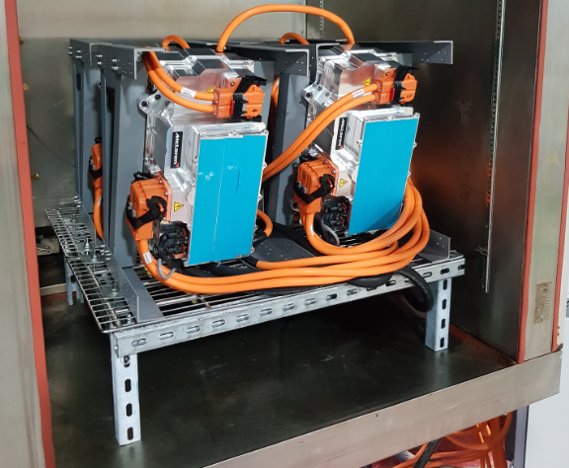

## Remote Access

Remote access via VPN was very important for monitoring the test status and for troubleshooting issues. As discussed in [3.3.2], a more reliable method of remote connection may be required.

# Recommended Actions

## UUT Load Pulse Management

During testing there were some instances of load pulses getting stuck on for longer than they should have. This was because the command to turn off the load was missed/ corrupted.

Currently the production test code requires the test script to disable the inverter/DCDC load. It would be useful if a pulse duration could be specified so that the unit itself would disable the output. Another option would be to run the test using the unit’s application code, which would provide the necessary protections and be more representative of the final product.

## UUT Temperature Protection

During commissioning a unit was run without coolant and was subsequently damaged. There is IGBT thermal protection in the production test code set to 150°C, however this protection is not active when running in endurance test mode as the unit is stuck in initialisation. It should be reviewed if thermal protection can be added whilst in endurance test mode.

The IGBT temperatures shortly before the unit failed were reading 80 – 100°C, and it is estimated they would have been around 150°C at the point of failure. Another option would be to run the test using the unit’s application code, which would provide the necessary protections.

## Use an Updated Electronic Load

As discussed in [3.2.3], there were some issues with the EA EL-1960 electronic load. It is recommended to use e.g. EAs latest series that are Ethernet and SCPI compatible.

## Update Chiller Error Handling

An error experienced with the Huber Unichiller as described in [3.2.2] meant that the device would stop the temperature control of the coolant. The test only responded to this due to the increase in unit temperature and could respond quicker if the device was checked for errors and acted upon.

## Update logfile splitting

As discussed in [3.3.3], the handling of logfiles should be improved so that the creation of a new logfile is not blocked by the framework trying to rename the existing logfile. [Now complete in ATK V3.1.7].